

Aldershot Methodist Church

Art, Craft, Stories, Fun

Saturday 12th October
10.30am to 12pm

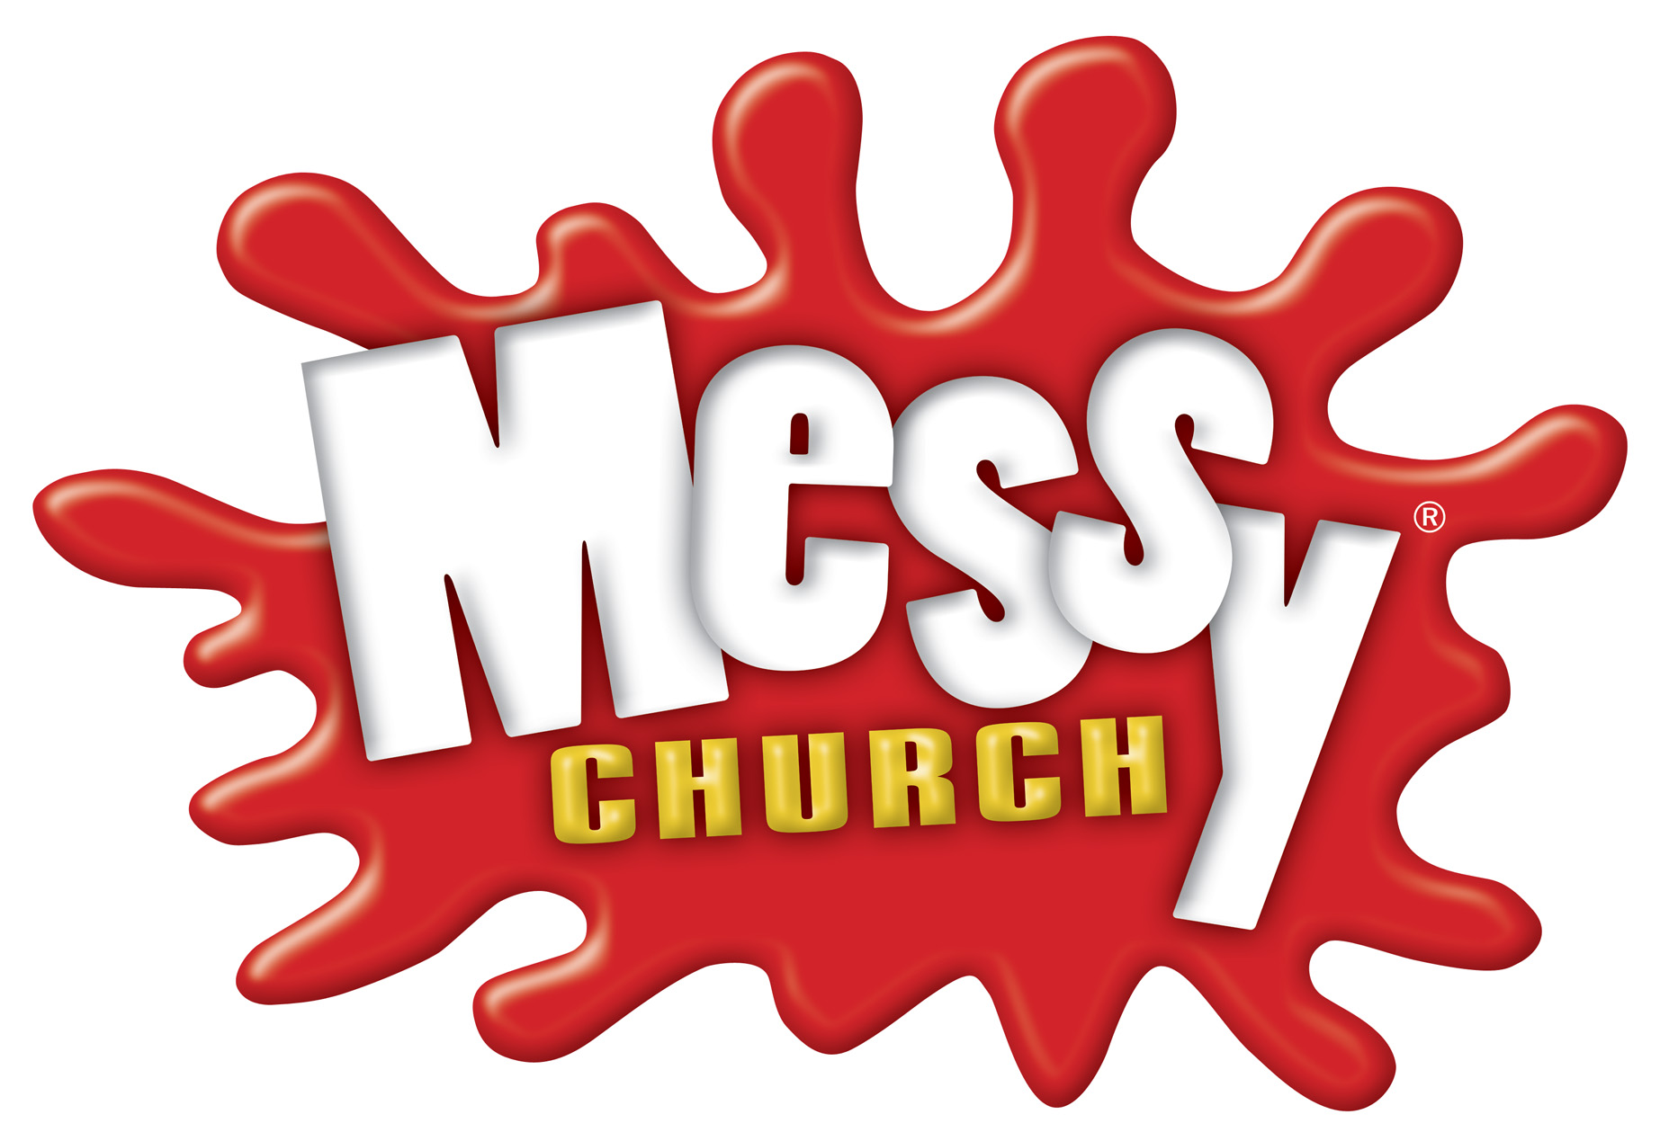
Messy Church is for adults and children
to enjoy together. It is all-age and fun.
All Welcome

